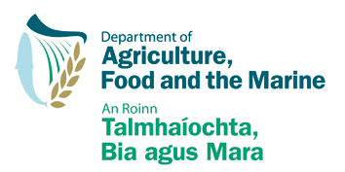

Registration of a Food Business Operation
under the European Communities (Food and Feed Hygiene)
Regulations, 2009 (S.I. No. 432 of 2009) as amended by S.I. 306 of 2015.

REGISTRATION FORM
SUPPLY OF RAW MILK BY A PRIMARY PRODUCER FOR DIRECT HUMAN CONSUMPTION, TO RETAILERS AND/OR FINAL CONSUMERS

Please complete this form in BLOCK CAPITALS.
If completed on screen, please print off a copy, and sign. Telephone: 057 8694358
Fax: 057 8694391
Address: Milk Hygiene Division Email: dairyhygiene@agriculture.gov.ie
Department of Agriculture, Food & the Marine
Pavilion B
Grattan Business Centre
Portlaoise, Co Laois, R32 KW50

Establishment or Person for which Registration is sought and contact details:

Legal Name:

Address:
Include Eircode

Telephone: Mobile Fax:
Ph:

Email:

Details of activity for which registration is sought

Herd No.: | Species of animal milk is sourced from  (cows/sheep/goats): | Approx. no. of litres per week for supply for direct human consumption: | Distance (in kms) of retailers/consumers from holding:
 |  |  | Nearest | Furthest

I wish to register, on behalf of the business described above, under Regulation 3 of S.I. No 432 of 2009 as amended by S.I. 306 of 2015, to use the premises at the address specified above for the purpose of the supply of raw milk for direct human consumption to retailers and/or final consumers.

Signature: ___________________________

Date: ___________________________

